
Charles Chieppo

Unions are the 1-percenters in Massachusetts

By Charles Chieppo
December 09, 2012
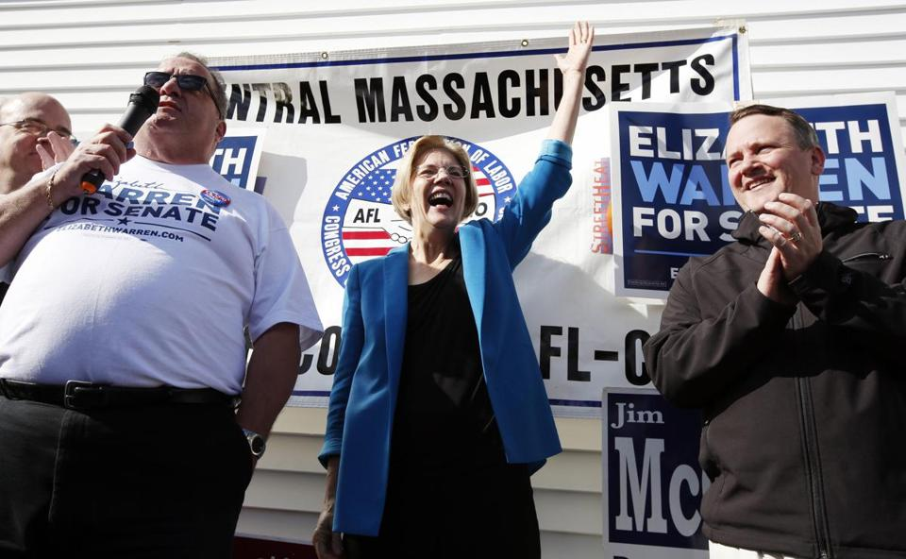
AP
Elizabeth Warren waves during a campaign rally with union workers in Auburn on Nov. 3.
Bottom of Form
DURING THE recent campaign, Massachusetts Democrats denounced widening income inequality and the excessive influence Wall Street and other big business interests have over our politics. On the national level, it’s a persuasive argument.
But here in the Commonwealth, electing the candidates who made those arguments was like voting to maintain the Bush tax cuts. Because in Massachusetts politics, organized labor is the ultimate 1 Percenter and the rest of us are Occupiers.
According to the state Office of Campaign and Political Finance, 17 of the 20 political action committees that contributed the most to Massachusetts candidates during the 2009 to 2010 campaign season (the last for which data are available) were labor organizations.
Just when their legendary political muscle seemed to be on the wane, labor pulled out all the stops for Senator-elect Elizabeth Warren and Congressman John Tierney, as they had for Governor Patrick in 2010. With those candidates’ wins, unions are stronger than ever here, and that’s bad news for Massachusetts.
More than 80 percent of the Commonwealth’s construction workforce is not affiliated with a union. But project-labor agreements — which effectively bar non-union workers — have recently been slapped on several large state construction projects (full disclosure: one of my clients is an association of open-shop contractors).
A study of school construction by Suffolk University’s Beacon Hill Institute found that PLAs increased construction expenses by at least 12 percent. The premium is due to fewer bidders and onerous union work rules, not any differential in how much workers are paid. All public construction is subject to state and federal prevailing wage laws.
Taxpayers understand that union-only construction needlessly increases costs and they’re in no mood to pay the premium. In a 2010 Suffolk University/7 News poll, 69 percent of state residents opposed compelling contractors to hire all their workers through unions.
At least 11 states, including Maine and even union-friendly Michigan, have banned PLAs on state-funded projects. But you can count on seeing more of them here.
The Patrick administration touts the fact that off-duty police are no longer the only ones who can serve as flaggers on road construction projects, yet opponents of the move point to miniscule savings. The reason for the lack of savings is simple: The administration categorizes civilian flaggers as construction workers, which means they too fall under prevailing wage laws that prevent cities and towns from paying flaggers the kind of wages they make in every other state.
Candidates of all stripes profess their undying devotion to small businesses. To his credit, Governor Patrick is streamlining regulations that affect them. But don’t expect to see any changes in the Commonwealth’s onerous independent contractor law, even though that’s the reform that might help small businesses the most.
My wife has operated a small gardening business for 12 years. Like many home-based businesses, she is able to offer those who work with her a flexible schedule built around their kids’ school days. In any other state, the workers would be independent contractors. But in Massachusetts they can’t be covered under her liability insurance unless they are classified as employees.
The law is designed to inflate the costs of open-shop construction companies that routinely underbid union firms, but its unintended consequences ripple through the state economy. Is it any wonder that Massachusetts has fewer jobs than it did two decades ago, even as the number of jobs has increased by 25 percent nationwide?
Public employee unions have their own perks. The so-called Pacheco Law all but eliminates competition from private entities that might be able to provide a service more efficiently than state employees. The law begins by requiring the cost of a private contract to be compared against what public costs would be were state employees to work “in the most cost-efficient manner.” From there, it only descends further into a land of make-believe.
Nationally, 2012 was largely a status quo election. But those fighting against the thumb big business sometimes places on the scales of equity can point to some progress.
No such luck in Massachusetts, where the labor organizations that are the richest political players of all got even richer.
Charles Chieppo is the principal of Chieppo Strategies, LLC, a public policy writing and advocacy firm.

