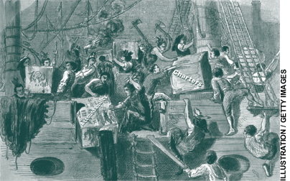

Accountability Overboard
By Charles D. Chieppo and James T. Gass
Special interest groups opposed to charter schools and high-stakes testing have hijacked the state’s once-independent board of education and stand poised to water down the MCAS tests and the accountability system they support.

President Barack Obama and Massachusetts governor Deval Patrick are both brilliant orators who espouse the “politics of hope.” Both know about hope firsthand, having overcome less-than-privileged backgrounds to achieve great success. Patrick endorsed Obama early in the campaign and is a close advisor. That closeness got Obama in trouble during the primaries, when he was caught cribbing lines from some of Patrick’s speeches. More recently, Patrick chaired the platform committee for the Democratic National Convention that nominated Obama.
But we can only hope their similarities don’t extend to education policy. Patrick calls education his “singular pursuit.” Yet after winning election in a 2006 landslide fueled by strong support from the Bay State’s powerful teachers unions—including $3 million in contributions—he has pursued the systematic dismantling of reforms that have made Massachusetts the national leader in public education.
The Massachusetts Education Reform Act of 1993 dramatically increased school funding in return for high academic standards, accountability, and enhanced school choice. In the years following, the Commonwealth’s independent board of education, founded in 1837 with Horace Mann at the helm, implemented a set of reforms that have unquestionably been the nation’s most successful.
In 2005, Massachusetts became the first state ever to finish first in four categories of the National Assessment of Educational Progress (NAEP): 4th-grade reading and math and 8th-grade reading and math. The next time the test was administered, Bay State students did it again. Late last year, results from the Trends in International Mathematics and Science Study (TIMSS) demonstrated that Massachusetts students are not only the best in the country, they are globally competitive as well. The Commonwealth’s 8th graders tied for first in the world in science and were sixth in math; 4th graders scored second in science and third in math.
Despite the clear success of more than a decade of education reform in Massachusetts, Governor Patrick’s administration has turned its back on the very forces behind that success: it is wavering on standards, choice is under continual fire, and the board of education has been stripped of the independence that for 170 years was Horace Mann’s legacy and had allowed the board to implement reform with a singular focus on improving student achievement.
In June 2008, Governor Patrick released the recommendations of his “Readiness Project,” an unwieldy 168-member, 13-subcommittee behemoth charged with developing a long-term “action agenda” for education. The plan calls for full-day kindergarten, universal pre-K, consolidation of school districts, and differentiated pay for teachers—all worthy goals. But the report maintains Patrick’s steadfast resistance to raising caps on charter schools. (Charter schools have the same effect on some of his supporters in the education establishment as Nancy Pelosi has on Rush Limbaugh.) Although the governor claimed during his campaign that he would open more charter schools once he “fixed” the formula by which they are funded, the Readiness Project is virtually silent on charters and their funding.
The Boston Globe, which enthusiastically endorsed the governor in both the Democratic primary and the general election, was not impressed. An editorial titled “Adrift in the edu-sphere” noted, “It’s nice to explore the educational cosmos. But taxpayers can’t be expected to pay for such a trip…when the likely cost of implementing Patrick’s full-blown plans could exceed $2 billion per year.”
Yet another commission, this one tasked with determining how to pay for Patrick’s action agenda, was appointed in June 2008. By the time its report was released, in the midst of a snowstorm on New Year’s Eve, the bottom had fallen out of the economy. Instead of identifying revenues to support new programs, the report focused mostly on cost-saving measures designed to preserve the current level of quality, although a majority of the commission’s 23 members did endorse raising the Commonwealth’s sales tax from 5 to 6 percent.

Success Story
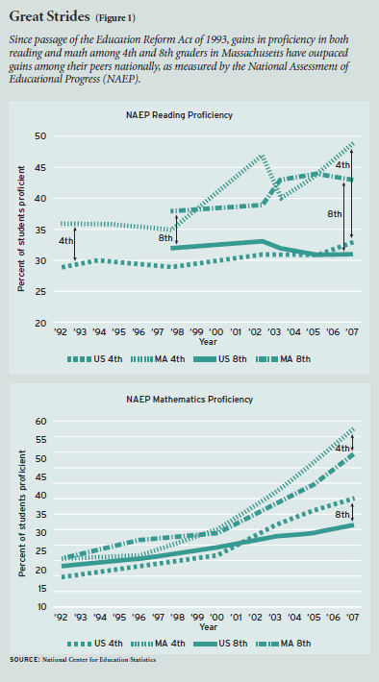
All of this is particularly bizarre in light of the dramatic strides the state has made in improving its schools. The U.S. Chamber of Commerce published a state-by-state report card on educational effectiveness in 2007 that rated the Commonwealth’s public schools number one in the nation. The combination of funding, standards, accountability, and choice has brought real, measurable gains in student achievement (see Figure 1). A look at the condition of public education prior to reform shows just how far Massachusetts has come. During the 1980s, the Commonwealth’s verbal SAT scores were below the national average; math scores were below average as late as 1992. A funding system that was overly reliant on local property tax revenue created vast discrepancies from district to district in student achievement, class size, and the availability of resources like textbooks, libraries, and technology.
Since 1993 the Commonwealth has pumped more than $40 billion in new state money into public education, matched by $40 billion-plus in new local funding. Each district’s foundation budget, the minimum expenditure needed to provide an adequate education, is determined by formula, along with the amount each city and town can afford to contribute. The Commonwealth fills in the gap between the local contribution and the foundation budget. The result is a funding formula in which the vast majority of state education aid goes to the poorer school districts, making Massachusetts one of the national leaders in this respect as well (see Figure 2).
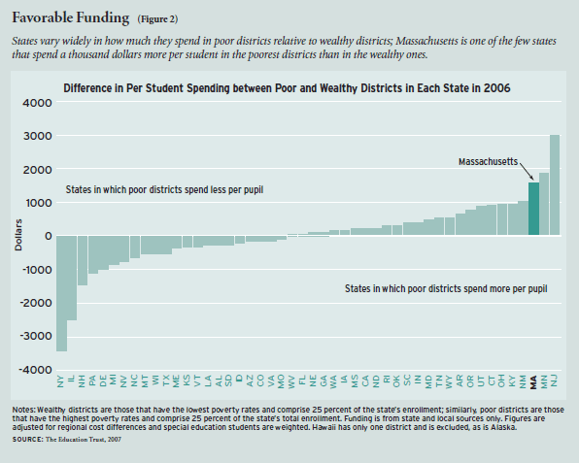
To ensure high academic standards and school-level accountability, state curriculum frameworks provide a subject-by-subject outline of the material that should form the basis of local curricula. To ensure implementation of the frameworks, students are tested each spring. Since 2003, passing the Massachusetts Comprehensive Assessment System (MCAS) tests (based on the liberal arts-rich content of the frameworks) has been a high school graduation requirement. High-stakes testing also extends to new teachers, who must pass tests that measure communication and literacy skills as well as subject-area knowledge.
The state’s NAEP scores shot up after the curriculum frameworks were completed and the MCAS test was first administered in 1998. By 2007, the average Massachusetts 4th grader was performing at a higher level in math than the average 6th grader had been in 1996. Achieve, Inc., a national education organization established by governors and business leaders, found in 2001 that Massachusetts was the only state among the 10 it examined that had both strong standards and strong assessments. A 2007 study by the Massachusetts Board of Higher Education confirmed the tests’ validity, finding a strong correlation between MCAS results and college performance.
Noted educator and developer of the Core Knowledge curriculum E. D. Hirsch lauded the Massachusetts approach in a February 2008 op-ed in the Washington Post. “Consider the eighth grade NAEP results from Massachusetts, which are a stunning exception to the nationwide pattern of stagnation and decline,” he wrote. “That is because Massachusetts decided…students (and teachers) should learn explicit, substantive things about history, science and literature, and that students should be tested on such knowledge.”
Choice and Charters
In Massachusetts, public charter schools are the principal vehicle for offering educational choice, and the Thomas B. Fordham Foundation has described the Commonwealth’s charter-school approval process as the nation’s most rigorous. Today, roughly 25,000 students (about 2.6 percent of the total public school population) attend Massachusetts charter schools, and another 21,000 are on wait-lists. Admission to an oversubscribed school is by lottery. When a student chooses to transfer to a charter school, funding follows from the district to the charter school. Despite the fact that districts are reimbursed for three years after a student leaves (100 percent the first year, 60 percent the second, and 40 percent in the third) and despite the 2004 adoption of district-friendly changes to the charter-funding formula, the flow of money has made charter schools controversial.
That controversy has fueled a one-step-forward, two-steps-back treatment of charters over the years. Caps on the number of schools have been raised just twice and now stand at 72 for the original type (known as Commonwealth charter schools) and at 48 for Horace Mann charters (a unionized, in-district model sanctioned after Commonwealth charters were established). Other limitations have been placed on both types of charter schools. The statewide share of public school students who can attend charters is capped at 4 percent. In any year in which a new charter school is approved, at least three of the newly approved charters must be located in low-performing districts. The law limits to 9 percent the portion of district spending that can be transferred to charter schools. More than 150 communities, mostly in poorer areas with low-performing schools, are bumping up against that cap, which places a de facto moratorium on charters.
Charter school results have been strong. A 2006 Massachusetts Department of Education study found that 90 percent of charter schools performed as well as or better than the districts from which their students came and 30 percent outperformed sending districts by a substantial margin. Their success has been particularly striking in urban areas, where most charters are located. Several urban charter schools, like Community Day in Lawrence, and MATCH, Boston Prep, and Excel Academy in Boston, serve overwhelmingly low-income and minority populations, yet outscore even the best suburban schools on MCAS tests.
SABIS International Charter School in Springfield is among the schools that have had remarkable success in narrowing achievement gaps based on race and economic status, a clear priority for the next phase of education reform. By 10th grade, Hispanic and African American students, who together make up 60 percent of the school’s student body, outperform white students statewide on the MCAS English exam and are virtually even with statewide averages for white students in math. More than 2,500 students sit on the school’s waiting list. Every member of all seven graduating classes has been accepted to college.
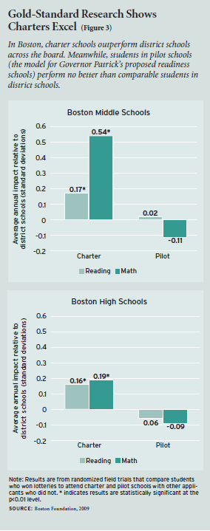
A study conducted by a team of Harvard and MIT researchers and published in January by the Boston Foundation showed that Boston charter schools dramatically outperform both district and pilot schools (semi-autonomous district schools created in response to charters). It found that the academic impact from a year spent in a Boston charter is comparable to that of a year spent in one of the city’s elite exam schools and, in middle school math, equivalent to one-half of the achievement gap between black and white students (see Figure 3).
One might expect the governor would support schools that the state’s own analysis and others have found to be successful. Indeed, prior to release of the Readiness Project recommendations, Governor Patrick said, “Everything is on the table because our future is at stake.” Everything, it seems, except expanding the kind of educational choice that transformed the governor’s own life.
Patrick earned a scholarship from A Better Chance, an organization that provides educational opportunities to young people of color. The scholarship transported him from the South Side of Chicago to Milton Academy, an elite Massachusetts preparatory school, and put him on a trajectory that led to Harvard, a top position in the U.S. Department of Justice, the corporate world, and ultimately the governor’s office.
But the Readiness Project includes precious little that would give others the opportunity to choose their school. The Readiness Project proposes “readiness schools,” which would have some of the autonomy of charter schools and some of the features of pilot schools. Teachers in a district school could come together and vote to convert to a readiness school, or districts could initiate the conversion. As an inducement to adopt the newly proposed schools, S. Paul Reville, whom Patrick appointed first to chair the state board of education and then as secretary of education, floated the possibility of a freeze on charter schools in districts that embrace readiness schools. When the trial balloon became public, he quickly backpedaled in the face of a torrent of opposition.
The administration’s current position on the charter freeze is unclear. When questioned, Patrick said the charter school debate had reached “stalemate” and his plan includes new ways to achieve the same goals.
Dismantling Success
In 2000, the Commonwealth created the Office of Educational Quality and Accountability (EQA) as an independent state agency to measure the effectiveness of school-district managers at implementing reform. Beginning in 2002, EQA conducted comprehensive audits of more than 175 school districts. The audits scrutinized MCAS performance, district leadership, curriculum and instruction, teacher and student assessment and evaluation, and business and financial operations. All findings were made public.
Soon after taking office, Patrick moved to eliminate the EQA. Opponents particularly disliked the agency because it did its job so well—auditing school districts and reporting when they came up short. Two studies by Boston-based think tank Pioneer Institute analyzed agency data and found that low-performing urban districts in particular were not aligning curricula with state frameworks and not using MCAS data effectively to improve achievement by tailoring lessons to student weaknesses.
More than a year after the EQA was scuttled, the co-chairs of the state legislature’s Joint Committee on Education filed a bill, later enacted, creating a new Advisory Council on District Accountability and Assistance. The new agency amounts to the fox guarding the accountability henhouse, replacing the EQA’s independent 5-person board with a 13-member panel that includes representatives of the very people it’s supposed to audit: the Massachusetts Association of School Superintendents; American Federation of Teachers Massachusetts; Massachusetts Teachers Association; Massachusetts Association of School Committees; Massachusetts Secondary School Administrators Association; and the Massachusetts Elementary School Principals Association.
The administration’s proposal to overhaul the Commonwealth’s education governance structure gained legislative approval in February 2008. An education commissioner who reported to the board of education, not the governor, had long directed primary and secondary public education in Massachusetts. The Patrick proposal resurrected the state secretary of education post, which had been created and abolished twice since the 1970s.
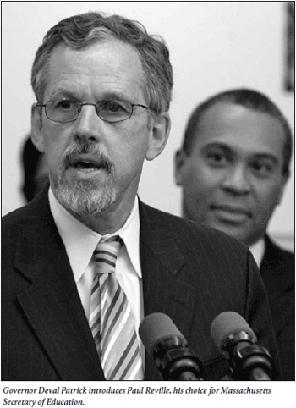
Reville, who then chaired the board of education, claimed Governor Patrick’s plan kept appropriate distance between politics and education policy. But when a far weaker education secretariat had been proposed in 2003, Reville testified before the legislature in opposition to the plan, saying, “No matter how well constituted, an education secretariat creates a competing center of power that vies with and against the state’s chief school officer, the Commissioner of Education and the state education agency.”
Governor Patrick himself contradicted Reville’s claim that the new proposal was more respectful of independent education policymaking. At its unveiling, the governor said his plan “will be different in that (the secretary) will have real authority.”
But the administration’s main target was the state board of education. In a move reminiscent of FDR’s court-packing plan, the overhaul added two seats to the board, opened up two more slots by removing the commissioner of early childhood education and the chancellor of higher education, made the new secretary a voting member, and truncated the terms of members least likely to agree with the administration.
Even more importantly, it stripped the renamed Board of Elementary and Secondary Education of its independence, placing it firmly under the governor’s control by giving the new secretary final say over budget requests and veto power over its selection of future commissioners of education. The board had just selected Mitchell Chester, an Ohio education official, to be the next commissioner. Chester beat out Karla Baehr, who was superintendent of schools in the city of Lowell, had gained some prominence among urban superintendents (see sidebar), and was widely seen as the choice of the education establishment and the governor. Baehr was later hired as a deputy commissioner.
If It Ain’t Broke, Break It
On February 2, 2007, a group of urban school superintendents attended a State House meeting sponsored by a local education group. It was the kind of event at which everybody smiles and talks about the lofty goals they all share, rather than the multitude of issues they’re fighting about behind the scenes.
Immediately following the meeting, the urban superintendents met with Dana Mohler-Faria, education advisor to the newly elected governor Deval Patrick. They brought with them a memorandum that contained policy proposals that stood in stark contrast to the harmonious rhetoric heard just minutes before:
• Restructure the state board of education
• Eliminate the Office of Educational Quality and Accountability and district accountability
• Conduct an independent charter-school study (even though the state department of education had completed a comprehensive study of charter schools just months before)
• Reduce the transfer of district funds to charter schools and remove charters from the state education aid formula, thereby subjecting them to the annual appropriation process.
The memorandum would foretell much of the Patrick administration’s education policy over the next 18 months.
The usually affable Patrick also used the unveiling of his governance proposal to send a message to those concerned about charter schools, saying they should “grow up.” Later, after release of the Boston Foundation study, Patrick called the debate about raising charter caps “a red herring because we’re not at the cap,” despite the fact that Boston is among the urban communities bumping up against the 9 percent of school district spending limitation, with only 111 charter seats remaining and about 7,000 students languishing on wait lists.
In February 2008, the board, still chaired by Reville (he assumed the new secretary of education post on July 1), became the first to reject a charter school recommended for approval by the commissioner of education. The focus of the board’s discussion about the proposed SABIS regional charter school in the city of Brockton was a 2005 state department of education (DOE) report that identified problems at the Springfield SABIS charter school. Days after the new school’s application was rejected, a 2006 DOE letter surfaced that said the Springfield school had successfully addressed all the major issues raised in the earlier report. Company officials who attended the board meeting were not allowed to respond to Reville’s criticisms.
A Boston Globe editorial noted that the “rejection raises thorny questions about just how hard the Patrick administration is willing to push to achieve equity in education.” Like SABIS’s successful Springfield charter school, the proposed school would have served troubled communities. The most current data available prior to the proposed school’s rejection showed that 20 of Brockton’s 23 schools failed to make adequate yearly progress (AYP) under federal law, and all 6 failed to make AYP in nearby Randolph, where the schools are in such bad shape the district was required to submit a plan to stave off state receivership. During the board’s debate over the proposed charter school, Patrick appointee and board PTA representative Ruth Kaplan commented that charter schools are too focused on sending students to college, saying “families…don’t always know what’s best for their children.”
During the spring of 2008, Reville charged a “21st Century Skills Task Force” with rewriting curricula and ensuring that Massachusetts students are prepared to succeed in a fast-changing economy. The task force’s report, published in November, proposes revamping MCAS and using the U.S. History test to try out project-based assessments that require students to demonstrate skills like “global awareness,” a change likely to crowd out topics like the Constitution or causes of the Civil War. It calls on the teachers unions, school committees, and superintendents that have fought education reform for 15 years to determine how to integrate 21st-century skills in our schools.
In a sad irony, the task force report claims that “Massachusetts can learn from the experience of West Virginia” on ways to incorporate the needed skills. West Virginia students score below the national average on the NAEP tests, and the state was among the seven that saw the largest declines in reading scores between 1998 and 2005.
A month after release of the task force report, former state senate president Thomas Birmingham, one of the architects of education reform, delivered an address in which said he was “discomforted” by the direction of the Readiness Project and that the 21st Century Skills Task Force “may threaten to…drive us back in the direction of vague expectations and fuzzy standards.”
Teacher testing has also come under fire. In April 2008, the state senate voted to allow some teachers to be licensed even if they failed the required exam three times. The administration announced that it was looking at alternative criteria for aspiring teachers, even though most of the tests are at a high-school level of difficulty. Reville told the Globe the test “isn’t necessarily the best venue for everyone to demonstrate their competency.”
The move to back away from teacher testing sparked another firestorm of opposition. In a Boston Globe op-ed, Charles Glenn, then dean ad interim of Boston University’s School of Education, wrote, “It would be a gross disservice for our public school children to be taught by teachers who do not meet the standards set by our current teacher tests.” Reville later said the administration didn’t support the senate vote after all.
With the pillars of reform under attack, Joe Williams, executive director of Democrats for Education Reform, wrote in the Globe, “You have to wonder why Massachusetts seems intent on retreating from its own nationally recognized success. The backward slide is already evident.”
The Wrong Path
The Commonwealth’s 15-year track record of successful education reform gave Governor Patrick a clear path ahead on education policy. Instead of undoing the reforms of his predecessors, the governor could have built on the state’s success by carrying on the commitment to high standards, fine-tuning a successful accountability system, and maintaining the governance structure that had successfully insulated critical education policy decisions from special-interest pressure. He could extend to others the educational opportunity that transformed his own life by raising from 9 to 20 percent the cap on the amount of money that can be transferred from school districts to charter schools in districts whose MCAS scores are in the bottom 10 percent statewide.
So far, he has chosen instead to dismantle reform and replace the singular focus on student achievement that was the key to education reform’s success with a wish list that would likely cost taxpayers an additional $2 billion per year. With the new Board of Elementary and Secondary Education stripped of independence, there is no entity left that can operate outside the political arena with the sole mission of improving academic performance.
Results released in September 2008 showed a sharp drop in MCAS pass rates and flat or declining scores in the elementary and middle school grades and in many urban districts. While 15 years of progress will not be undone overnight, as the Patrick administration’s efforts to dismantle reform continue, such drops are likely to become the rule. It is the price we will pay for Massachusetts policymakers snatching defeat from the jaws of the Commonwealth’s historic education-reform victory.
As for President Obama, during the primaries he played to the teachers unions that are a critical Democratic Party constituency by assailing the evils of forcing teachers to “teach to the test.” But once the nomination was secured, he moved to the center, unveiling proposals that included merit pay for teachers and doubling federal charter-school funding. His selection of Arne Duncan, Chicago’s charter-friendly school superintendent, as education secretary also bodes well. Let’s hope that as president he continues down that path rather than the one Governor Patrick has chosen, and that he applies the lessons from the successful reforms in Massachusetts to federal education policy.
Charles Chieppo is a senior fellow and James Gass is director of the Center for School Reform at Pioneer Institute, a Massachusetts public-policy think tank.

