

Top of Form

Better, Faster, Cheaper

Detroit's Cruise to Nowhere

The region's port authority tapped the taxpayers for $22 million to build a dock for cruise ships. It's not working out so well.
by Charles Chieppo | September 1, 2015
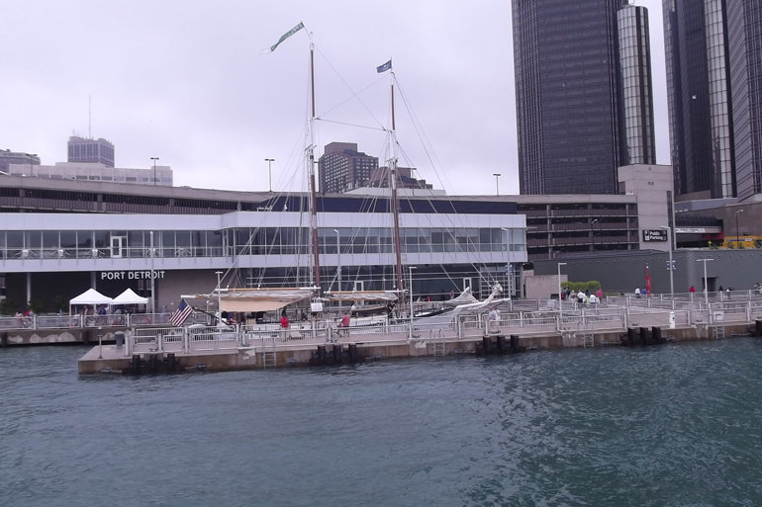
Since the Detroit/Wayne County Port Authority spent $22 million building a facility to entice cruise ships to dock there, only one has. (FlickrCC/Lauren)

Those who doubt the ability of some state and local government officials to make harebrained investments with tax dollars should turn their attention to Detroit, where the local port authority's 2011 construction of a public dock and terminal is making their counterparts who invest in sports stadiums and convention centers look like Warren Buffett.
When the Detroit/Wayne County Port Authority built the $22 million Carl M. Levin facility, named for Michigan's longtime former U.S. senator, the idea was to entice ships from the growing Great Lakes cruise market to dock there. The good news is that dockings are up; the bad news is that they're holding steady at one so far this year after coming in at zero for all of 2014.
The ship that did dock in Detroit this summer liked it and wanted to return. But when it tried, U.S. Customs officials refused to staff the terminal so passengers could disembark. According to a Customs spokesperson, "The facility … has not been completed and does not meet the IT and security requirements necessary to properly process cruise vessels and/or cruise passengers. These and other issues were discussed with the Detroit Port Authority over four years ago."

RELATED
- Can Massachusetts Get Its Tax Giveaways Under Control?
- Another Beanball for the Taxpayers
- Is It Worth Spending $111,000 to Create One Job?
- A Chance to Get Sports Teams Out of Taxpayers’ Wallets
- Want a Tax Credit With That Popcorn?
Yet even this mess has its defenders. Port Authority Executive Director John Loftus and Port Authority Commissioner Alisha Bell trot out the old warhorse that the facility attracts jobs and visitors. Numerous studies, of course, have documented that projects like these rarely stimulate economic activity on a level that comes anywhere close to justifying their costs. (In fairness to Loftus, the project was built before he became executive director.)
Bell makes another argument for the project: "It's a beautiful space for weddings and events that enhances our visibility." Weddings, in fact, seem to be the terminal and dock's main business. Continental Services, a catering firm whose founders are big contributors to local officials' election campaigns, holds them there. The company also owns a luxury yacht and offers party cruises from the dock. Lest you think that the fees from weddings and party cruises cover the $22 million facility's costs, all of $140,000 was collected from the company last year.
Top of Form
Bottom of Form
Top of Form
Even though the terminal and dock isn't a city project, such wasteful spending is particularly hard to stomach in Detroit, where local residents have already endured so much. The city's 2013 bankruptcy declaration, the biggest municipal bankruptcy in American history, has forced retirees to absorb genuinely painful pension cuts. Detroit's population is down to around 700,000 from a high of 1.9 million. So much land has been abandoned that one of the revitalization strategies being pursued is urban farming.
Elective politics rarely attracts small egos, so it's only natural for officials to want to do big things. But good government is rarely sexy. Sometimes it requires resisting the siren song of projects that rely on patently unrealistic economic assumptions. That's particularly true when those who can least afford it -- such as the taxpayers of a suffering region -- are picking up the tab.
Charlie_Chieppo@hks.harvard.edu


Charles Chieppo
Charles Chieppo is a research fellow at the Ash Center of the Harvard Kennedy School.
Part of

Better Faster Cheaper
with Steve Goldsmith
Harvard Kennedy School


