

Top of Form

Better, Faster, Cheaper

The Mixed Picture of What the States Owe

Their debt challenges may not be as bad overall as has been portrayed, but some of them are in serious trouble.
by Charles Chieppo | June 12, 2014
When it comes to getting your arms around just how much states really owe, there is no shortage of moving parts. There's bonded debt, and then there are liabilities for pensions and for other post-employment benefits such as retiree health care.
Dig deeper and you find that states set different periods over which they aim to pay down liabilities and that they assume differing rates of return on investments. Some states use fixed annual payments, but many use a gradually increasing schedule that results in payments being backloaded.
This column appears in our monthly Better, Faster, Cheaper email newsletter. Click to subscribe.
A new report from J.P. Morgan performs an important service by showing how states would stack up if all of these major variables were standardized. The study's author, Michael Cembalest, assumes a 6 percent rate of return on investments, level annual payments and a 30-year term for paying down liabilities.
Despite nearly $1.5 trillion in debts and unfunded retirement obligations, the study finds that, overall, state liabilities don't amount to the kind of national crisis that has often been portrayed. That is, unless you live in one of the states that face some very difficult choices because their debt and retirement costs are at or above a quarter of state revenues.
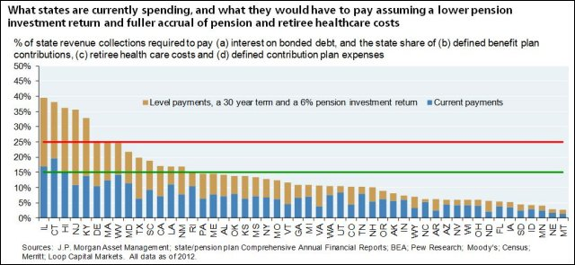
Cembalest finds that states with a liability-to-revenue ratio of 15 percent or less are in pretty good shape, and 36 states fall into that category. But eight states are in trouble. Given all the attention its pension problems have garnered, it's no surprise that Illinois is the worst, but wealthy Connecticut isn't far behind. Five of the eight (Delaware, Hawaii, Illinois, Kentucky and New Jersey) would have to more than double their annual payments to get their debt and retirement liabilities under control. The other two states on the watch list are Massachusetts and West Virginia.
The 6 percent rate of return Cembalest assumes on state investments is below historical averages, but it represents a much safer strategy than the 7.5-8 percent that most states assume. Such rosy assumptions result in gaping budget holes during tough economic times when states are least able to plug them.
While it might seem to make sense to increase annual retirement-liability payments each year on the assumption that inflation increases payrolls over time, too high a rate of annual escalation results in backloaded contributions that can understate long-term liabilities.
Perhaps as a result of the attention devoted to public-pension costs in recent years, 29 states made their full annual required contribution (ARC) to their pension funds in 2012. But the cost of other post-employment benefits (OPEB) is an even larger burden than pension liabilities in Hawaii and Delaware, and it is equal to pensions in Connecticut, New Jersey and West Virginia.
Despite the magnitude of the problem, just seven states made their full ARC toward paying down OPEB liabilities that year. Montana and Nebraska contributed nothing.
If the J.P. Morgan report is correct, most states have dodged a bullet. But to avoid a future crisis, they must do a better job of both calculating and addressing long-term liabilities. Massachusetts, for example, uses a debt affordability analysis calibrated to ensure that debt-service costs don't exceed 8 percent of budgeted revenue in any future year.
In addition, state taxpayers can no longer shoulder the entire downside risk for pensions. As I have argued before, they should transition to a system under which employees have a choice between defined-contribution and cash-balance plans.
The majority of states that face manageable debt and retirement liabilities can rightfully breathe a sigh of relief. But unless they get more conscientious about long-term liabilities, they won't be so lucky in the future.
Charlie_Chieppo@hks.harvard.edu


Charles Chieppo
Charles Chieppo is a research fellow at the Ash Center of the Harvard Kennedy School.
Part of

Better Faster Cheaper
with Steve Goldsmith
Harvard Kennedy School



