



How New Orleans is Rebuilding Its Ruined School System from the Ground up
POSTED BY CHARLES CHIEPPO | MAY 28, 2013

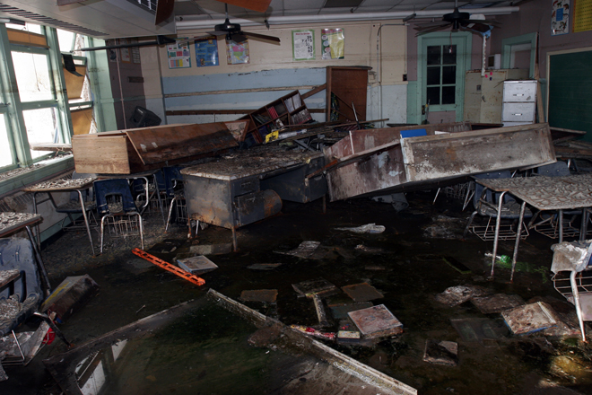
A classroom in New Orleans in the wake of Hurricane Katrina. (Photo: AP/Bill Haber)

What would public schools look like if you could pretty much start them from scratch? Almost everyone has a different answer, but few would describe the traditional schools or school districts we have today. Since Hurricane Katrina, New Orleans has had the chance to do just that--albeit for a reason you wouldn't wish on anyone--and the results have been impressive.

Pre-Katrina, New Orleans' schools were among the nation's worst. As a college-admissions counselor in the 1980s, I spent several days each fall visiting New Orleans-area high schools. During that time, I visited exactly one New Orleans public school: Benjamin Franklin, a selective high school reserved for the city's best students. Even there, the facilities were so bad that I had to meet with students in a bus outside the school.

Academics and facilities weren't the district's only problems. At one point before Katrina, New Orleans' schools were so corrupt that the FBI set up a satellite branch in the school board's central office.

After Katrina, all the city's teachers were laid off and officials turned 63 schools over to the state-run Recovery School District (RSD). RSD had been established in 2003 to turn around the city's failing schools, but before the 2005 deluge it had taken over only five. RSD immediately sought charter-school operators to manage as many as possible. The state education board retained oversight over two city charter schools. Sixteen more schools that were still considered viable remained under the elected local school board's control; 12 of them soon sought charter status.

Today, more than 80 percent of New Orleans public school students attend charter schools and the rest attend schools operated by RSD. The city has no traditional district schools.

Spending money in the classroom instead of on school-district bureaucracy has served the city well. Before Katrina, only 35 percent of New Orleans' public school students passed state tests; now that figure is 60 percent. The graduation rate has climbed from 55 percent to more than three-quarters, and the percentage of students attending failing schools has fallen from three-fifths to less than one-fifth. It the current rate of improvement holds, New Orleans is less than five years away from becoming the only major American city in which student test scores exceed state averages.

Even with all the good news, problems are inevitable in a school system that has been rebuilt on the fly in the wake of a natural disaster. It's good that RSD has been strict about shutting down failing schools, but its approach is overly rigid. Rather than measuring schools on rate of improvement, decisions are based on performance on state tests. Quality should be measured by how much students improve; basing it on absolute performance creates an incentive to exclude low-performers.

Another problem is RSD's exclusive focus on college-prep schools. As Massachusetts' experience with vocational-technical education has shown, academically rigorous voc-tech schools that equip students to meet the challenges of a 21st-century economy should be a critical part of public education.

Finally, in a city in which 88 percent of public-school students are African-American and 85 percent qualify for free or reduced-price lunches, there is a dearth of African-American teachers to serve as role models. In the years immediately following Katrina, one-third to as many as half of New Orleans' teachers were from Teach for America, a program of mostly white graduates of elite colleges. Teach for America now accounts for about a quarter of the city's teachers, and the city's improved schools are creating a pipeline for future New Orleans teachers.

Despite the inevitable imperfections, New Orleans has done an outstanding job of re-imagining public education. The hope is that it won't take a Katrina for other urban school systems to apply that city's hard-learned lessons.


Charles Chieppo
Charles Chieppo is a research fellow at the Ash Center of the Harvard Kennedy School.
E-mail: Charlie_Chieppo@hks.harvard.edu
Twitter: @governing

