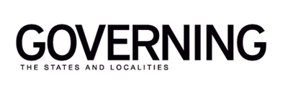

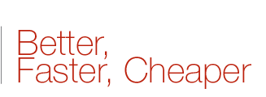

Rolling the Dice with Taxpayer Money
Posted By Charles Chieppo | October 25, 2012
The recent bankruptcy filing by A123 Systems, a maker of batteries for electric and hybrid cars, once again shines a spotlight on the use of government subsidies to aid individual companies. In A123's case, it was the federal government that awarded the company nearly $250 million in stimulus money, but states don't exactly have an admirable track record when it comes to this issue.
Massachusetts loaned money--$5 million--to A123, but that's just the tip of the states-as-venture-capitalist iceberg. State investments in private companies generally come in two forms. The first is grants or loan guarantees, such as the $75 million that Rhode Island taxpayers lost when the state invested in former star pitcher Curt Schilling's failed video-game company, 38 Studios. The other is tax breaks and other tax incentives. Massachusetts provided a combination of grants and tax breaks that added up to more than $30 million for Evergreen Solar, a clean-energy company that declared bankruptcy last year.
Either way, it's a bad deal for taxpayers. States aren't very good at venture capitalism because it's a skill very few public officials have. For them to roll the dice on a specific company is like me joining a high-stakes Las Vegas poker game. The difference is that I'd lose my own money in Vegas. When states play venture capitalist, they play with taxpayer money.
States don't do much better when they use tax breaks to try to lure specific companies. In the wake of the Evergreen fiasco, Massachusetts officials formed a Tax Expenditure Commission to review the Bay State's web of tax breaks, also known as "tax expenditures."
The commission pegged overall foregone state revenue from tax breaks (not just those for businesses and economic development) at an estimated $26 billion this year, more than the total amount of tax revenue the commonwealth expects to collect during the fiscal year. And a 2011 analysis by the state auditor of 91 business tax breaks offered that year found that only a few came with mechanisms for reviewing their effectiveness or recovering lost revenue if the breaks failed to produce the hoped-for economic benefits.
In addition to being ill-suited to investing in individual companies, states also shouldn't subsidize specific industries, as with the federal oil-industry subsidies that, along with investments in companies like A123, have become an issue in the presidential campaign. What state governments can do is create opportunities by funding research through public universities or other outlets. Companies can then compete to put the fruits of that research to the most lucrative use.
A123 reminds us that the federal government isn't so good at picking winners and losers. But the evidence is clear that states are no better. Both taxpayers and state revenues would be best-served if state officials realize their limitations, focus on creating an environment of economic opportunity and let the market sort out the details.


Charles Chieppo
Charles Chieppo is a research fellow at the Ash Center of the Harvard Kennedy School.
E-mail: Charlie_Chieppo@hks.harvard.edu

