

Top of Form

Better, Faster, Cheaper

Boston’s Public-Transit Snow Job

The region's transit system is crippled by more than terrible weather. It's suffering from decades of irresponsible financial decisions.
by Charles Chieppo | February 20, 2015

Boston has endured over seven feet of snow in less than a month, and the most visible casualty has been the region's decrepit transit system. A closer look at the woes bedeviling the Massachusetts Bay Transportation Authority (MBTA) reveals a more-than-20-year guide to how not to run a transit system, and the lessons don't only apply to systems that have to contend with mountains of snow and extreme cold.
The MBTA's struggle with this winter's weather has become national news. Massachusetts Gov. Charlie Baker's frustration grew as the system was unable to restore service after each storm, causing MBTA General Manager Beverly Scott to announce her resignation. She then said it would be 30 days before full commuter-rail and subway service could be restored -- if there were no more snow in the interim.
Meanwhile, the economic cost to the region of the system's inability to move its 1.3 million daily riders mounts.
It's a mess that could easily have been avoided. The problems trace back to 1991, when state officials signed a consent decree with a local environmental advocacy group that had sued to stop construction of Boston's now infamous "Big Dig" unless the state agreed to build new transit projects as environmental mitigation for the additional cars that the transportation megaproject would accommodate.
The consent decree bound the state to complete 14 new projects, including subway extensions and new commuter-rail lines. It set the MBTA on a path to being the fastest-growing major transit agency in the country even though it serves a relatively slow-growing metropolitan area. No funding source was identified for any of the expansions.

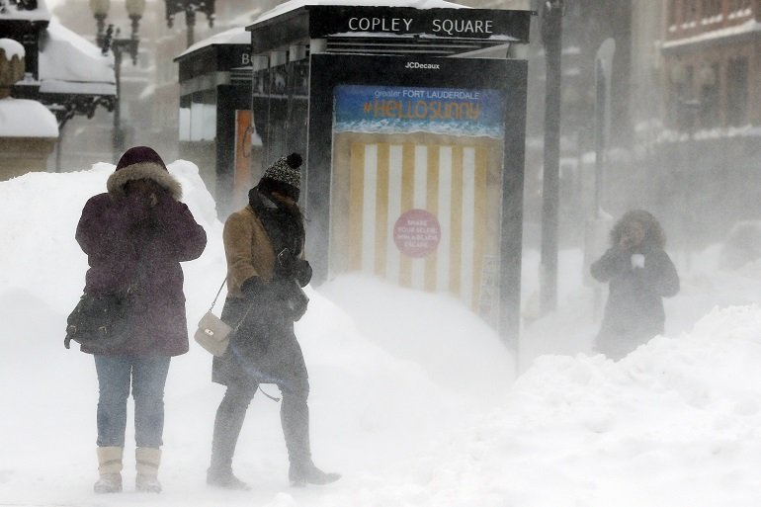
Pedestrians brace against blowing snow in Copley Square in Boston on Feb. 15. AP/Michael Dwyer

Almost a decade later, in 2000, a law was enacted to "forward fund" the MBTA. Believe it or not, the previous funding system consisted of the authority informing the legislature what it had spent during the previous year and the legislature cutting a check to cover it.
Under forward funding, the MBTA would get the revenue from one penny of the state sales tax and assessments from the municipalities it serves in addition to the revenue it could raise from such sources as fares, parking, advertising and rent on its extensive property holdings. The bonds sold to build the mandated new transit lines also became the MBTA's responsibility.
But before the ink was dry on the forward-funding legislation, the phenomenon of tax-exempt Internet sales began to eat away at sales-tax receipts. It also quickly became clear that parts of the MBTA finance plan were unrealistically optimistic.
By 2002, the MBTA's financial problems were obvious. Reports published in 2007 and 2009 detailed the problems. But state leaders did little, limiting themselves to raising the sales tax in 2009 and modestly increasing the gas tax four years later. By then it was too little too late.
Today the MBTA owes nearly $9 billion in debt and interest, which translates into more than one-quarter of its operating revenue going to debt service. And since money that should have funded maintenance had to be diverted to the legally mandated expansions, the system faces an estimated $5 billion maintenance backlog. Trains, buses and signal systems that should have been retired decades ago have been no match for this winter's cold and snow.
The MBTA debacle holds two major lessons for other transit agencies. First, don't undertake expansions without knowing how they'll be paid for. And see that paying for them includes operations, maintenance and debt service, not just construction costs.
Second, elected officials must have the courage to ensure that transit systems have sufficient funding to meet their critical maintenance and other needs. By kicking the can down the road and waiting years to address the MBTA's looming crisis, state leaders turned a multimillion-dollar problem into a multibillion-dollar disaster -- and that's before accounting for the staggering toll the system's meltdown is taking on the local economy.
The long-term silver lining here may turn out to be Beverly Scott's announcement that it will take at least 30 days to restore full service. With every day that customers can't access trains and buses and motorists must contend with the resulting congestion, it becomes less likely that voters will allow their elected representatives to forget about the MBTA's problems once the snow finally melts.
Charlie_Chieppo@hks.harvard.edu


Charles Chieppo
Charles Chieppo is a research fellow at the Ash Center of the Harvard Kennedy School.
Part of

Better Faster Cheaper
with Steve Goldsmith
Harvard Kennedy School


