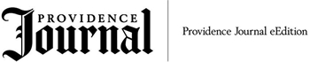

Charles Chieppo and Jamie Gass: Break the chains on charter schools in Mass.
September 20, 2013
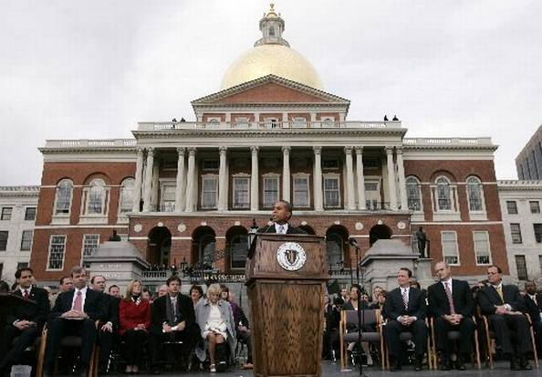

Governor Patrick in front of state house in Boston

By Charles Chieppo and Jamie Gass
Boston
What did Massachusetts’ legislators and governor do between April and August this year? They passed a budget, permanent tax increases, a two-day tax holiday, raises for judges, and a long list of local bills dealing with things like water storage in Fall River and police detail work in the town of Harvard, and sewer easements. Over a dozen acts created sick leave banks for specific state and county workers.
Some of these laws had merit; others were debatable or even wrong-headed.
But something is upside down when our legislators won’t find the time to debate and pass a law that would ensure that families in 29 troubled school districts can send their kids to good schools.
As state government slept, a very important thing happened in Boston: The last charter-school seat available under the current cap was filled. For months, a bill that would lift the charter cap in Boston and other low-performing school districts has languished.
The need to enact the legislation is clear. A Stanford University study published earlier this year found that Boston charter schools are doing more to close achievement gaps than any other group of public schools in the country. Each year, the typical Boston charter student gains the equivalent of over 12 months of additional learning in reading and 13 more months in math.
One would expect a report from a highly respected source that concludes that Boston has the highest-performing charter schools in the country would serve as a wake-up call for legislative leaders.
But we have long known about the opportunity Massachusetts charter schools provide. A 2009 Boston Foundation report found that Boston charter schools dramatically outperformed both district and pilot schools (semi-autonomous district schools created in response to charters). It found that the academic impact from a year spent in a Boston charter was comparable to that of a year in one of the city’s elite exam schools and, in middle-school math, equivalent to one-half of the achievement gap between black and white students.
Massachusetts Comprehensive Assessment System (MCAS) test results tell a similar story. Last year 20 charter schools, including many urban charters, finished first in the commonwealth on various tests. Many inner-city charter schools outperform even affluent suburban schools.
Meanwhile, nearly one-quarter of New Bedford Public School students failed the 10th grade math MCAS test last year. In Fall River, 17 percent failed the same test. In science, the percentage of students scoring in the “advanced” category — the highest of four scoring categories — was in the single digits for both districts.
It’s not just a South Coast problem. Holyoke, Lawrence and Springfield scored worse than Fall River on MCAS; Lawrence did even worse than New Bedford.
For more than 15 years we have seen a parade of charter-school alternatives, all designed to placate adults in the public education system, achieve results that pale in comparison to those delivered by charters.
One reason for the multiple attempts at “charter lite” was the argument that charter schools drain money from their traditional counterparts. That claim no longer passes the smell test. The Legislature has repeatedly sweetened reimbursements to districts that lose students to charter schools. Today, those reimbursements stretch on for six years after a student’s departure.
Boston has moved ahead of the state on the charter cap issue: Most of the city’s top-tier mayoral candidates support charter-school expansion. They know that few things would do more to reduce unemployment, attract middle-class families to the city and cut crime than high-quality public education.
To make progress on those issues, Boston’s next mayor needs the Legislature and governor to wake up from their months-long slumber. State officials will always work on mundane issues — it’s part of their job. But if they cannot attend to the big issues (and inequities) of our time, they should find another line of work.
In New Orleans, it took a natural disaster to get political leaders to address a school system that was in crisis long before Hurricane Katrina hit. Unlike New Orleans, Massachusetts has the advantage of a reform that is already a proven success at closing race- and income-based achievement gaps and extending opportunity to all students. It shouldn’t take an act of God for the Bay State’s leaders to do the right thing and lift the cap on charter schools in the commonwealth’s lowest-performing school districts.
Charles Chieppo is a senior fellow and Jamie Gass directs the Center for School Reform at Pioneer Institute, a Boston-based think tank.

