

Top of Form

Better, Faster, Cheaper

A Transit System’s Self-Inflicted Wounds

The D.C. region's Metro system is facing one serious problem after another. What's needed is a new focus on serving its customers.
by Charles Chieppo | September 17, 2015
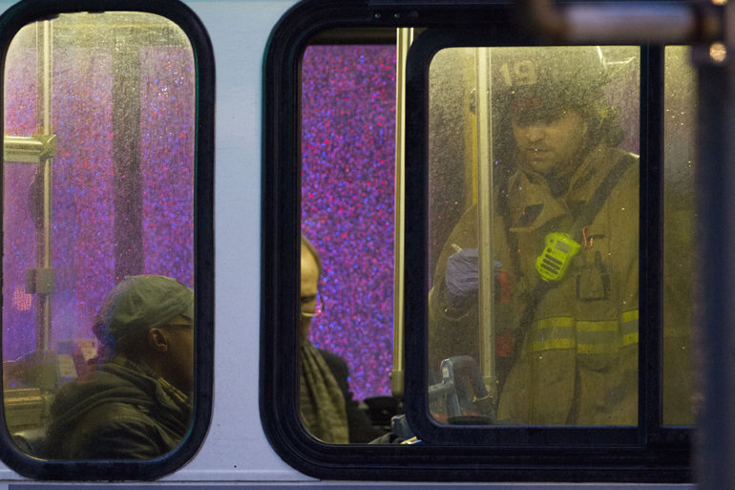
A firefighter helps passengers on a bus after people were evacuated from a smoke-filled Metro subway tunnel in Washington, D.C. (AP/Jacquelyn Martin)

It's been a tough year for the Washington Metropolitan Transit Authority, and many of Metro's wounds have been self-inflicted. But the problems experienced by the transit system, whose subways are the nation's second-busiest, may finally have unleashed the forces needed to turn it around.
Anyone who doubts the toll that Metro's troubles can take on the Washington, D.C., region need only look at the paralysis and economic losses that ensued when the Boston area's Massachusetts Bay Transportation Authority collapsed last winter under the weight of record snowfall and years of skimping on maintenance.
Snow isn't the cause of Metro's recent troubles. In January, an electrical-component meltdown filled a subway tunnel with smoke, killing one person and making 80 more sick. Last month, a train derailment snarled service for a day. And the authority has been without a permanent chief executive since January.

RELATED
- A Public Transit System That Works
- Tardy Transit? Tweet About It
- Boston’s Public-Transit Snow Job
- The Transportation Choices That Millennials Want
In response to the smoke incident, a Federal Transit Administration (FTA) report found inadequate training, understaffing and failure to follow through on efforts to improve safety in the wake of a 2009 subway crash that killed nine people.
The report found that Metro has authorized the hiring of 54 controllers -- the people responsible for routing subway trains -- but that it only has 34 of them. As a result, the controllers often work six or seven 12-hour shifts a week, and supervisors still struggle to fill all the slots.
Then there are the self-inflicted financial wounds. A separate FTA review raised questions about Metro's finances and management, leading the feds to stop the automatic flow of federal grant money and requiring the authority to apply for each chunk.
The result is a slow and inconsistent trickle of all-important federal dollars. Metro has already spent $400 million it hasn't yet received. It has applied for only $175 million and may never get the entire amount because it failed to keep the timesheet records needed to be reimbursed for the costs that some of the grants cover. To make matters worse, the authority was unable to borrow money on the bond market because a federally required internal fiscal-2014 financial audit was delayed and not completed until last month.
It's no surprise that Chris Barnes, curator of the Twitter account @FixWMATA, which has more than 3,600 followers, recently called the authority's condition a "death spiral." But now customers are rising up. The new WMATA Riders Union recently held an organizational meeting. Its initial goal is to secure rider representation on the authority's board, where the union that represents Metro's workers is represented but riders are not.
Changing that is the first step in the transformation to a customer-service-driven organization that will be necessary for Metro to bounce back. It's the only way to reverse the decline in ridership and increase system revenues.
A customer-service focus means prioritizing maintenance investments that enhance safety, comfort and reliability and addressing rider complaints such as the failure to communicate service updates in a timely manner.
It shouldn't take a crisis for the Washington Metropolitan Transit Authority to get its act together, but nothing is better at getting the message across that Metro doesn't have a divine right to either riders or federal money. The best way for any transit agency to attract both is to make customer service the number-one priority.
Charlie_Chieppo@hks.harvard.edu


Charles Chieppo
Charles Chieppo is a research fellow at the Ash Center of the Harvard Kennedy School.
Part of

Better Faster Cheaper
with Steve Goldsmith
Harvard Kennedy School


